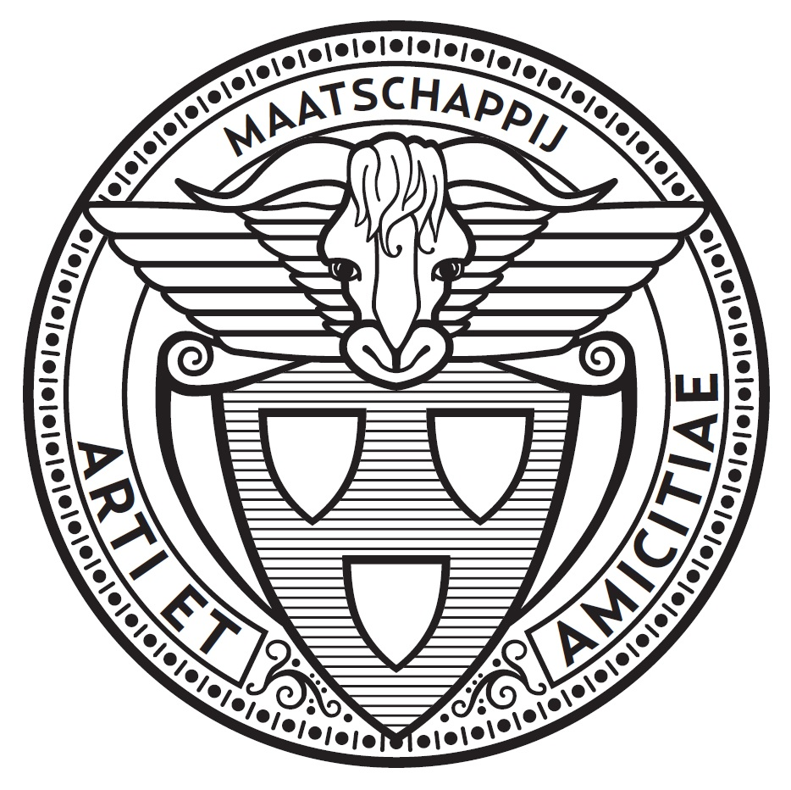
Application Form
exhibitions Arti et Amicitiae

Title exhibition:
Curator / curators:
Artists who have pledged:

Desired period:

Number of rooms:

Art disciplines:

Short description of the contents of the exhibition + participating artists
(max 750 words)

Funds where subsidies may be applied for:
1. Deadline:
2. Deadline:
3. Deadline:

Budget / resources:

Are sponsors working together?
If so with which?

Special wishes regarding the construction exhibition? A-V equipment? Painting? Loose walls Light?

Random programming (lectures, guided tours, education, performances, etc.)

Please send in filled out mail to Marjo Boeijen: marjo@arti.nl
with the following attachments in one pdf:
- CV. curator / curators (past 5 years)
- CV. participating artists (past 5 years)
- explanatory statement exposition (max 750 words or 2 pages)
- documentation of selected work for the exhibition: (with explanation: artist, material, size, year)
- Explanation: Why at Arti? Please describe briefly.
- budget (plan A and plan B)
- per plan (newspaper, social media, radio, flyers etc.)

